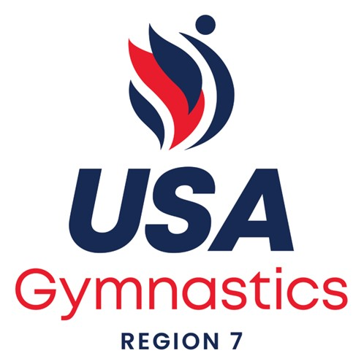

2026 REGION 7 HIGH PERFORMANCE TRAINING CAMP

Fact Sheet

Who: All Level 10s who competed at 2026 Dev Nationals, including All Star Session, 1st Alternates to Region 7 Team at Dev Nationals, and Level 9s who scored a 37.00 or higher AA at 2026 Eastern Nationals, are invited to register! Gymnasts MUST attend with a coach! Note: If we do not fill the camp after July 30, we will open registration to additional Level 9 and 10s.

ALL COACHES AND JUDGES MUST RENEW THEIR USAG MEMBERSHIP AND COMPLETE SAFE SPORT CERTIFICATION PRIOR TO THE CAMP. YOU CAN REGISTER FOR THE CAMP BEFORE RENEWING MEMBERSHIP AND SAFE SPORT.

Date: August 28-30, 2026

Location: First State Gymnastics
609 Tower Lane
Middletown, DE 19709

Registration and Fees:
Registration Open July 15-July 30, 2026. NO REFUNDS after August 18th.
All Gymnasts and coaches must register via Meet Maker. See link here:

http://www.meetmaker.com/meetdetails?eid=9135

Be sure to include your athletes’ graduation years!!

Athletes and coaches:

Registration only: $250.00 per gymnast (includes leotard and athlete party)

*All athletes must be registered and in attendance with a coach.
**Coaches bringing gymnasts will receive a Region 7 GIFT. (Max 2/club free for coaches attending the clinic). Additional gifts may be purchased on site after all registered coaches/clinicians have received their gifts.

Coaches registering without an athlete: $50.00. Please email Jen Bortz at JBortz7rac@gmail.com your name, membership #. Payment will be made via check onsite.

Hotel:

Holiday Inn Express and Suites
315 Auto Park Drive, Middletown, DE
Tel: (302)696-2272
Link: First State Gymnastics
Deadline: 8/1/26

General Schedule:

FRIDAY:
6:30-7:30pm Registration/Sign-in
7:30-9:00pm Camp Opening at First State

SATURDAY:
8:00-11:30pm Warm-up and Rotations
11:30-1:45pm Lunch and Rest (on your own)
11:45-1:00pm All-Star Team Meeting (First State)
11:45-1:45pm Judges’ Clinic (First State)
1:45-4:30pm Warm-up and Rotations
4:30-5:30pm Open Gym
6:30-9:30pm Athlete Pizza and Dance Party (First State)
Coaches/Judges Dinner including Dev Update and SIYA (See if You Agree!!) (Crooked Hammock Brewery)

SUNDAY:
8:00-12:00pm Warm-up and Rotations
12:00-12:30pm Closing and Awards
12:30pm Departure
1:00pm-4:30pm NCAA Showcase (for Level 10s not registered for High Performance Camp

IMPORTANT DETAILS:

Athlete party:
Where: First State Gym, 609 Tower Lane, Middletown, DE 19709

When: Saturday, 6:30pm-9:30pm
What: Pizza Party with Karaoke, Games and Fun!

Coaches/Judges/College Coaches Party:
Where: Crooked Hammock Brewery Middletown
316 Auto Park Drive, Middletown, DE
When: Saturday, 6:30pm-9:30pm
What: SIYA (See If You Agree), Dev Update, Hospitality

Team Building Fundraiser:

Check the attachment for our annual fundraiser for the Lynn Perrott Memorial Scholarship!!

